# Machine Learning Basics:

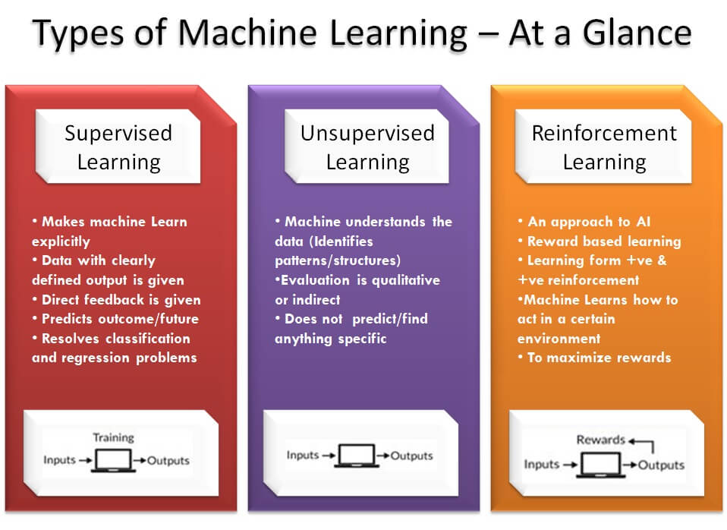

## Machine Learning Algorithms:

### **Supervised ML**

- here is how, in general, supervised algorithms work:

- you feed it an example input, then the associated output

- you repeat the above step many many times

- eventually, the algorithm picks up a pattern between the inputs and outputs

- now, you can feed it a brand new input, and it will predict the output for you

There are two types of Supervised learning problems. These Supervised problems can be further grouped into regression and classification problems.

**Classification Problems:** Classification problem can be defined as the problem that brings output variable which falls just in particular categories, such as the “red” or “blue” or it could be “disease” and “no disease”.

**Regression:** A regression problem is when the output variable is a real value, such as “dollars” or it could be “weight”.

### **Supervised ML Algorithms List:**

1. Decision Trees
2. Naive Bayes Classification
3. Support vector machines for classification problems
4. Random forest for classification and regression problems
5. Linear regression for regression problems
6. Ordinary Least Squares Regression
7. Logistic Regression
8. Ensemble Methods

### **UnSupervised ML:**

- here is how, in general, unsupervised algorithms work:

- you feed it an example input (without the associated output)

- you repeat the above step many times

- eventually, the algorithm clusters your inputs into groups

- now, you can feed it a brand-new input, and the algorithm will predict which cluster it belongs with

Unsupervised learning problems can even be grouped ahead into clustering and association problems.

**Clustering:** A clustering is that problem which indicates what you want to discover and this helps in the inherent groupings of the data, such as grouping the customers based on their purchasing behavior.

**Association:** An association rule is termed to be the learning problem. This is where you would be discovering the exact rules that will describe the large portions of your data. Example: People who buy X are also the one who tends to buy Y.

### **Supervised ML Algorithms List:**

1. K-means for clustering problems
2. Apriori algorithm for association rule learning problems
3. Principal Component Analysis
4. Singular Value Decomposition
5. Independent Component Analysis

### **Reinforcement / Semi-Supervised ML:**

In Progress..

***Source & References:***

<https://www.newtechdojo.com/list-machine-learning-algorithms/>

**Video Tutorials – For Beginners:**

<https://www.youtube.com/watch?v=ukzFI9rgwfU&list=PLEiEAq2VkUULYYgj13YHUWmRePqiu8Ddy>